FSDI 105 – Assignment 3
Name: Charles Taggart
Theme: Local Storage
GitHub Pages Link: https://github.com/chucktagg83/project104.git
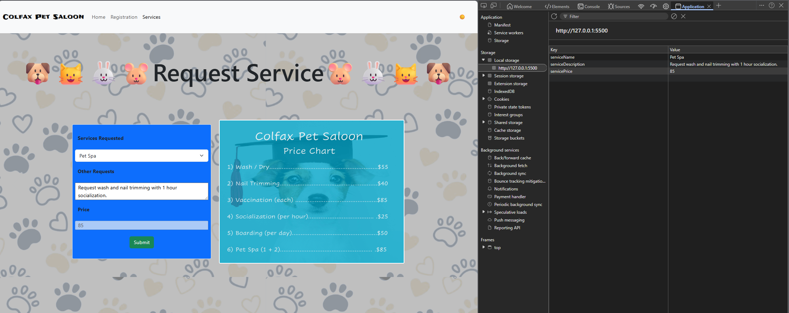
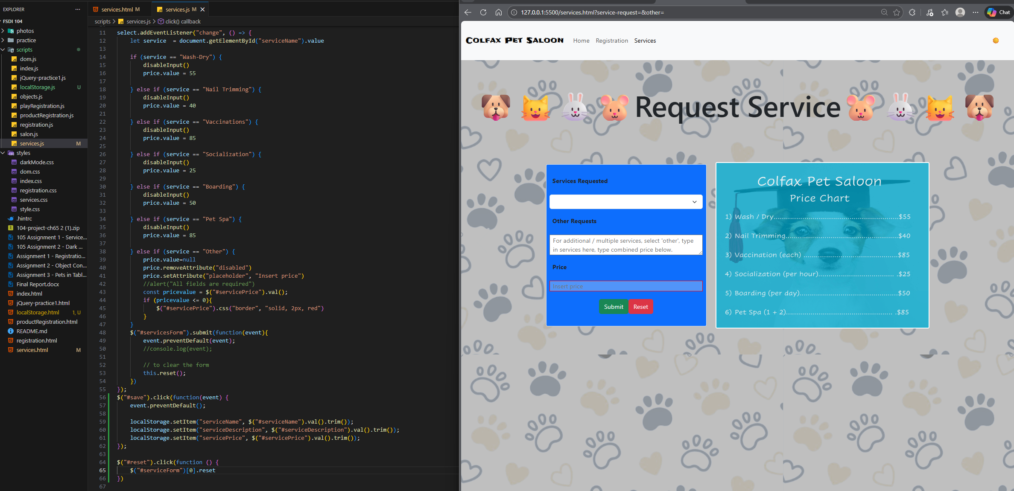

Summary of Edits:
- Added save on the local storage for form submissions.
- Added reset button and function for the inputs for services.
- Added the validation to the services page.

